SK Worm Promotional Items
Order Form for SWCDs & Nonprofits
(Dirt “T” Shirts $15.00 each for private purchases)
Shipping charges will vary; each order will include a shipping charge based on the size of the order.
Item | # | Cost | Total
Activity Book |  | $0.40 each
Coloring Book |  | $0.40 each
Mini Tattoos |  | $6.00/100
Dirt “T” Shirts |  | $12.00 each
Mini SK Worms |  | $45.00 each
Total
Shirt Sizes _________________________
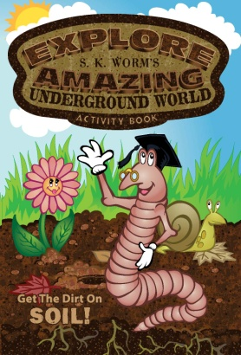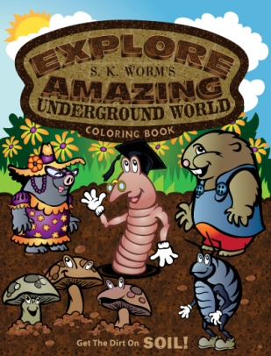
Activity Book Coloring Book Mini SK Worm
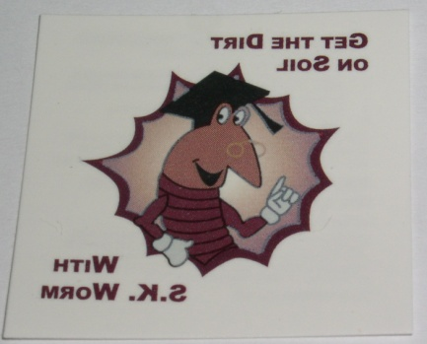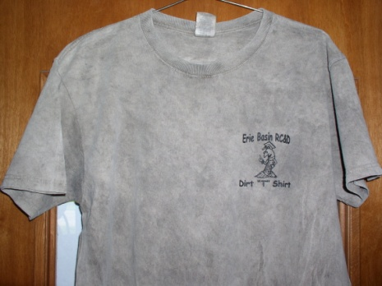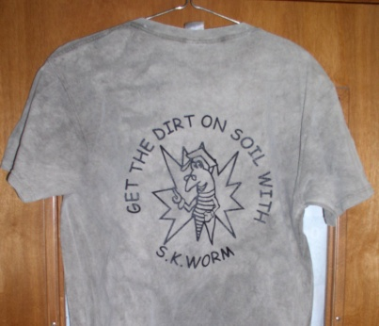
Mini Tattoos 1.5”X1.5” Dirt Shirt Front Dirt Shirt Back
Return this form or call Erie Basin RC&D at 419-681-6013 to place any orders.
Checks can be made payable to Erie Basin RC&D, 180 Milan Ave, Suite 9 Norwalk, OH 44857
“This Institution is an equal opportunity provider, and employer.”

